WHERE DO I START? 4 EASY STEPS
To use the free tool, follow the 4 simple steps to establish your own link to use EACH time you have food donations to track. If you want to take a test drive before establishing your own link, Try the DEMO by clicking on TRY IT NOW in orange.
ESTABLISHING MY OWN FOOD DONATION TRACKING LINK
STEP 1 Click on the BLUE FREE Link at the top of FoodRescue.net, and then click on the Green Let's Get Started button.
STEP 2 Click START, and provide your email, name, and state by scrolling down and clicking under each question, filling in the answer, and clicking OK or ENTER after each question.
STEP 3 Scroll down and click CONTINUE, and then click DATA ENTRY FORM
Congratulations! You have reached the USER PROFILE page!
Notice your email address is already entered. The User Profile page has a menu with a gray arrow/menu pointing down that has some advanced features for later. At this time, do not change the menu item from User Profile to something else. We will introduce those menu items at a later time. Type in the name of your school and click the gray "NEXT" button.
STEP 4 Name and state are already entered. If you would like a second person attached to a report each time such as a Food Service Director, add their email as an ADMIN. THIS IS NOT REQUIRED. Add the name of the city location of your school, and click SUBMIT
Check your email inbox or spam box.

RAW DATA EMAIL 1 AFTER AN ENTRY
Congratulations! Your custom online tracking link has been sent in an email, which gives you 2 ways to log food donations. Also, if you are signing up multiple schools, there is a convenient link to begin enrolling a new school. Included in the email are the following:
Dark Blue Button: LOG A QUICK FOOD RESCUE (meaning fast and easy)
Light Blue Button: LOG A DETAILED FOOD RESCUE (meaning more detailed)
Red Button: SIGN UP AND USE THIS TOOL (You have already done that. This is so you can forward the email onto other schools in your district to sign up.)
You may now start tracking food items donated! Just click either blue button and begin tracking food donations. Bookmark the link or email, and it becomes your "Home Base" to start every time you want to enter data and record a donation.

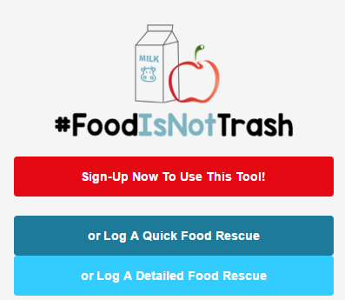
Figure 1. Screenshot of Email 1

K-12 FOOD RESCUE REPORT EMAIL 2 AFTER AN ENTRY
This email adds a GREEN BUTTON that says, CLICK ON IMPACT DASHBOARD. The "Impact Dashboard" is a spreadsheet that keeps a running total of your donations, and breaks it down into 3 categories:
1) Items Rescued
2) Meals Rescued
3) Pounds of CO2e Reduced, meaning CO2 (equivalents) prevented from entering the environment.
This allows your school and students to track the real impact of your efforts. It's a feature augments your totals to easily allow students to see the impact they are making by keeping unopened and un-peeled food items out of our landfills.
This link is a "VIEW ONLY", but the spreadsheet that can be downloaded for your own use. By clicking on the tab in the lower left hand corner that says FOOD RESCUE DATA, it will show every time stamped data entry you have ever made.
A PDF file is also attached on each report showing your ongoing totals.

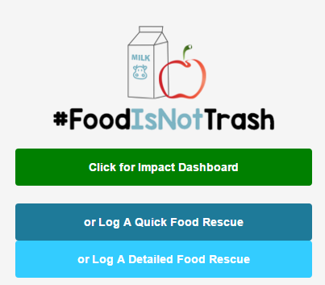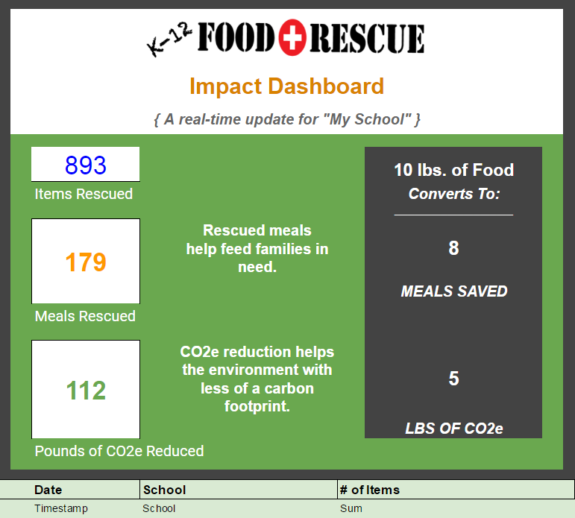
Figure 2. Screenshot of Email 2 Figure 3. Screenshot of Impact Dashboard
STEPS FOR LOGGING A QUICK FOOD RESCUE:
WHAT IS A QUICK FOOD RESCUE?
If your school just wants to track the total items of food, and not the specific items they donate, these are the directions you should follow. If you want to track your food donations in categories such as milk, fruit, snack bar, etc., the next page is for you.
STEP 1 Click log a quick Food Rescue at your "HOME BASE" email or link we suggested to bookmark, then click LOG A QUICK COUNT.
STEP 2 Type in how many total items are being donated or rescued, and click OK
STEP 3 Type in how many days worth of food this donation includes, and click CONTINUE.
STEP 4 Click CONTINUE again, then the gray NEXT button to FINISH THE QUICK COUNT.
STEP 5 (OPTIONAL) Place a check mark by anything included in the number of items you are donating. You will NOT be required to enter how many of each item has been donated, so areas can be left blank. If you have OTHER items donated that are not listed, click OTHER, and type the name of the item or items.
STEP 6 (OPTIONAL) Add another email to the report, or add a note, then click the gray NEXT button, then SUBMIT.
STEP 7 Check your Email box for your report for 2 emails:
1) RAW DATA: Tracks the information for the date of that exact donation, and
2) REPORT: Tracks the cumulative data of ALL entries made during the year.
This report not only emails you the results that were entered, but sends a PDF File of the report.
STEPS FOR LOGGING A DETAILED FOOD RESCUE
Thumbtack icons are for numbers, but can be left blank for zero.
STEP 1 Click log LOG A DETAILED FOOD RESCUE at your "HOME BASE" email or link we suggested to bookmark, then click LOG A QUICK COUNT, then click the gray NEXT button.
STEP 2 Click the gray arrow/menu that says "choose", and identify how many days worth of food is reflected in this donation entry.
STEP 3 Type in the TOTAL number of Cheese and Yogurt items separately.
STEP 4 IMPORTANT: Type in the total milks under Milk Count #1, and then put a check mark by "all". Leave all other milk options BLANK.
HOWEVER: If you choose to break the milk count into the 3 categories provided, in "Milk Count #1" type in the number of milks in that category, then identify the specific type of milk under "Milk Type 1 with a check mark. Repeat steps for Milk Count #2 and Milk Count #3 & Milk Type #2 and Milk Type #3.
STEP 5 OPTIONAL: Add other dairy totals, or add notes about totals. There are also some ADVANCED FEATURES, but for this tutorial, do not go to the menu for advanced features. Click the gray NEXT button.
STEP 6 Type in the count for Whole Fruit, Packaged Fruit, Packaged Vegetables, Juice, and Other items, and Click the gray "next" button. (SKIP ADVANCED FEATURES AGAIN)
STEP 7 COUNT DRY GOODS. On this category we are not breaking down the items individually. Just total them all as 1 total count, and then put check marks by the items that are included in that count.
STEP 8 Type the number of miscellaneous dry goods other than the ones listed in DRY GOODS TYPE. (SKIP ADVANCED FEATURES AGAIN) Then click the gray NEXT button.
STEP 9 If there are any other items, enter the number in the "COUNT: MISC ITEMS" area, and then describe what they are in the DESCRIBE MISC ITEMS area.
STEP 10 OPTIONAL: Add an new email address to receive the report, and add any notes. Then click the gray "next" button, followed by clicking the blue SUBMIT button.
STEP 11 Check your Email box for your report for 2 emails:
1) RAW DATA: Tracks the information for the date of that exact donation, and
2) REPORT: Tracks the cumulative data of ALL entries made during the year.
This report not only emails you the results that were entered, but sends a PDF File of the report.

