1) Students help keep daily stats by counting the unopened food, taking it to the cold and dry storage area, and tracking using our free online tracking tool.
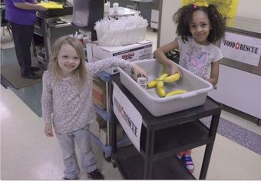 | 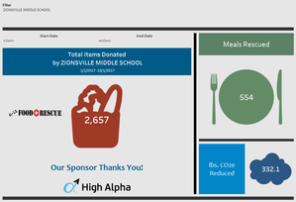
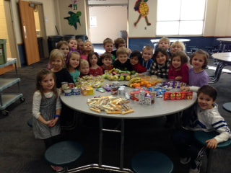
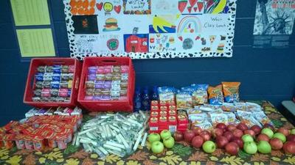
​2) Students take pictures or have pictures taken of their journey.

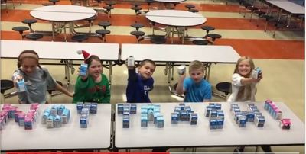
3) Students design ways to increase awareness of the programs existence. Posters, announcements, design the Food Rescue bins, and anything else that they can think of that would help students remember not to throw away unopened food.
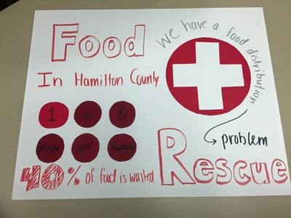

4) Students plan a volunteer system so that they can help the caring agency take the food to the vehicle of the caring agency, so the volunteer does not have to carry the food.
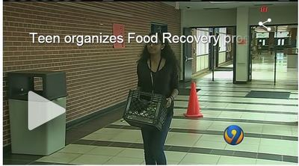
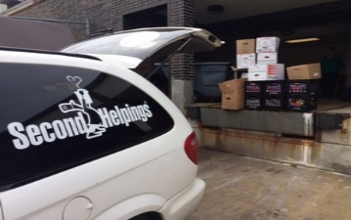

5) Student submit stories that are shared on the Food Rescue blog about their journey, discussing what they have learned, how much food they have kept out of a landfill, and how many pounds of methane gas they have prevented from entering the atmosphere.
