Breakfast or Lunch in the Cafeteria: Food Rescue Share Table and/or Donation

If a school does not participate in Share Tables, rather donations only, the same procedures apply.

- Follow the journey of an unopened and unwanted food item from the tray of the student to a Food Rescue Share Table/Cooler/Bin- to the cold and dry Food Rescue storage area- to the food pantry.
- Place a large Food Rescue cooler on ice for dairy and temperature controlled for safety food items along with signage. Temperature must be maintained at 41 degrees or colder and recorded as such at the beginning of the lunch period on a tracking sheet. Use any type of bin for a dry storage item, one that needs no temperature control.
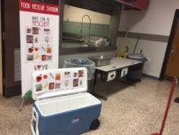
- After students sit down and eat, if they choose not to eat any item, they are allowed to place that item in the Food Rescue bin. Other students may come and take an item from the Share Table/Cooler/Bin if they are still hungry. This area should be supervised by a cafeteria employee or trained adult.
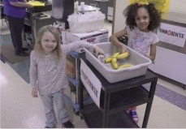
- After the lunch period is over, or between each lunch period, the food in the bins is taken back to the cold storage and dry storage area and identified as rescued food. Prior to the transfer, the total number of food items collected are recorded on a log in sheet, and the time and temperature of the bin are noted. Student learning and sense of ownership of the program is enhanced when they lead this process supervised by a trained adult.
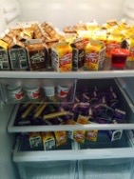
- After the day is over and food has been removed, ice is dumped from the cooler and the bins are washed, rinsed, and dried then returned to the Food Rescue designated area.
- On the day of the agreed upon pick date, a staff member or volunteer student group place the food items with protective restaurant type plastic gloves into the agreed upon bins the food pantry will use to transfer the food out of the school. If students are involved, it should be supervised by a cafeteria or trained staff member.
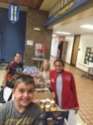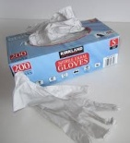
- Students, staff or volunteers take 30 seconds to log the total from the log in sheet on the clipboard sheet into the Free Food Rescue Online Tracking Tool, where they instantly receive their Impact Dashboard.
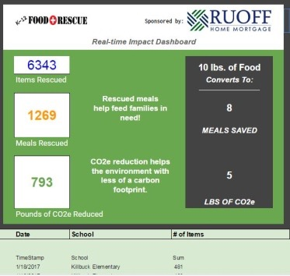

- Students are allowed to help the food pantry take the food to the vehicle of the food pantry volunteer or representative, or the volunteer can take it themselves. That decision is made by the school.
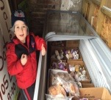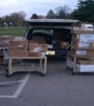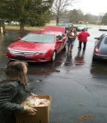
- Food arrives fully "rescued" at the food pantry, where it has been diverted from a landfill into the hands of children and families in need in the community.

Items Needed To “Get Started”:
1) A large cold storage cooler for temperature controlled for safety items, (TCS), small thermometer, and Food Rescue signage for the bin.
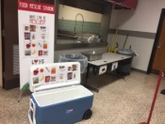
2) Plastic gloves for handling food
3) Smaller bins for dry storage: These are often preserved disposable cardboard boxes from food services, but can also be plastic crates, or plastic bins often seen in a restaurant.
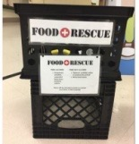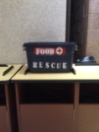
4) Clipboard and pencil to log food
5) Food Rescue Donation area separate from school food in both cold storage and dry storage areas. Can be separate and well labeled within a large walk in refrigerator, or it can be a separate refrigerator with a designated area.
6) Food Rescue Free Tracking tool: http://www.foodrescue.net/freetool.html
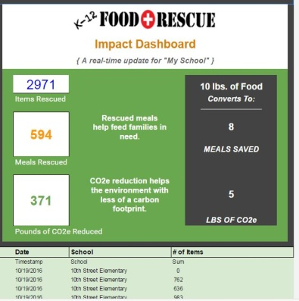
7) Frequently Asked Questions http://www.foodrescue.net/k12-faq.html

