Breakfast or Lunch in the Cafeteria: Food Rescue Share Table and/or Donation

If a school does not participate in Share Tables, rather donations only, the same procedures apply.

Follow the journey of an unwanted food item from the tray of the student- to a Food Rescue Share Table/cooler/bin- to the cold and dry Food Rescue storage area- to the food pantry.
Place a large Food Rescue cooler on ice for dairy and temperature controlled for safety food items along with signage. Use any type of bin for a dry storage item, one that needs no temperature control.
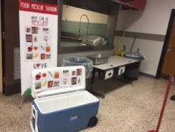
After students sit down and eat, if they choose not to eat any item, they are allowed to place that item in the Food Rescue bin. Other students may come and take an item from the Share Table/Cooler/Bin if they are still hungry. This area should be supervised by a cafeteria or trained adult.
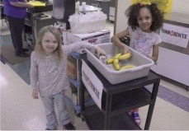
Between each lunch period, the food in the bins is taken back to the cold storage and dry storage area for rescued food and the process begins again. The total number of food items collected are recorded on a log in sheet.
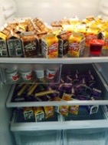
After the day is over, ice is dumped from the cooler and the bins are washed, rinsed, and dried then returned to the Food Rescue designated area.

On the day of the agreed upon pick date, a staff member or volunteer student group counts the food items with protective restaurant type plastic gloves prior to the arrival of the food pantry pick up. If students are involved, it should be supervised by a cafeteria or staff member.
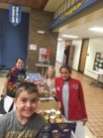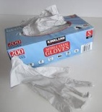
Students, staff or volunteers take 30 seconds to log the total from the log in sheet on the clipboard sheet into the Free Food Rescue Online Tracking Tool, where they instantly receive their Impact Dashboard.
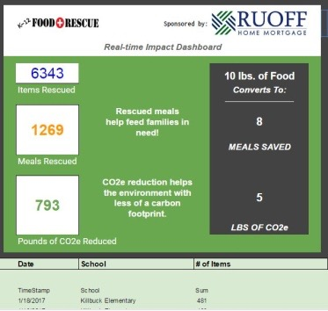

Students are allowed to help the food pantry take the food to the vehicle of the food pantry volunteer or representative, or the volunteer can take it themselves. That decision is made by the school.
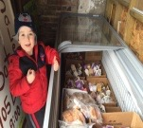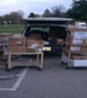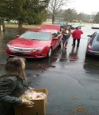
Food arrives fully "rescued" at the food pantry, where it has been diverted from a landfill into the hands of children and families in need in the community.
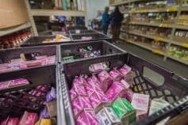
(see breakfast in classroom on page 3)
If your school has breakfast in the classroom, these modifications can be made.
For breakfast in the classroom, there are two options/variations:
1) Each classroom will have two Food Rescue bins-one for cold storage, and one for dry storage. Each classroom will assign a student or students to bring the cold storage and dry storage items from individual classrooms to the designated Food Rescue area for all cold and dry storage. Rescued items are then recorded on the log in sheet.
OR
2) A "student volunteer crew" will come around with a cart to each room with a large cooler with an ice bath to collect cold storage items, and they will pick up dry storage items in a separate bin. The "student volunteer crew" will then deliver the collected items to the Food Rescue cold storage and dry storage areas where all rescued food is stored and recorded on the log in sheet.
After breakfast is over, ice is dumped from the cooler, bins are washed, rinsed, and dried and returned to the Food Rescue designated area.

*Remaining procedures are identical from a cafeteria breakfast or lunch seen on pages 1-3.
(see what items are needed to get started on page 4)

Items Needed To Get Started:
1) A large cold storage cooler, small thermometer, and Food Rescue signage for the bin.
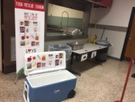
2) Plastic gloves for handling food
3) Smaller bins for dry storage: These are often preserved disposable cardboard boxes from food services, but can also be plastic crates, or plastic bins often seen in a restaurant.
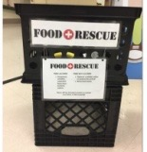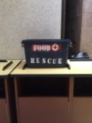
4) Clipboard and pencil to log food
5) Food Rescue Donation area separate from school food in both cold storage and dry storage areas. Can be separate and well labeled within a large walk in refrigerator, or it can be a separate refrigerator with a designated area.
6) Food Rescue Free Tracking tool: http://www.foodrescue.net/freetool.html
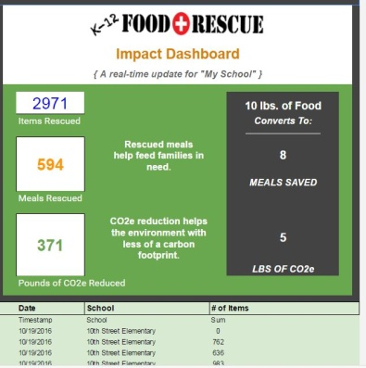

What items help roll the program out?
All video announcements and newsletter home to parent examples are on the K-12 FAQ landing page.
http://www.foodrescue.net/k12-faq.html
Where do I access the Food Rescue Free Online Tracking Tool?
http://www.foodrescue.net/freetool.html

